The Grand Lodge of Antient Free and Accepted Masons of Scotland
William Ramsay McGhee, MStJ, D.L., Grand Master Mason
Brethren
Here we are almost at the end of the 4th week of the lockdown and by all accounts it looks as if it will last for at least another three weeks. I hope and trust that you are managing to avoid the virus and keep safe.
In my last update, Mrs Dawn Oliff, our Homes Manager very kindly gave me an update on the Homes which was well received. Since last week the Homes have received some vital PPE kit courtesy of our Brethren in Lodge Rising Star of Western India No 342 and I acknowledge with grateful thanks their assistance. Marcus Humphrey House has also received a number of I-Pads from the Brethren of Renfrewshire West which will enable the residents to communicate with relatives during the lock down. Both gifts are another example of the tremendous work being done by members of the Craft everywhere.
Last week I told you of the success of the Zoom conference with the District Grand Masters. Following on from that a number of Provincial Grand Masters have suggested that we do the same for them. That being the case, I am looking at how we can best get that organised as I know some of the PGM’s have some good ideas that they’d like to discuss with their colleagues.
It has also been suggested by Past Grand Master, Brother Marcus Humphrey of Dinnet, Chairman of the Benevolence and Care Committee that we consider initiating a Covid-19 Appeal Fund to provide financial help to those in need – in the first instance, I would welcome any views that you may have and I will also discuss the issue with the PGM’s.
Some of you may have seen an article in the Times regarding a statement I allegedly made. The entire article was nothing more than a fabricated story. I can inform you that a complaint has been lodged with the Times.
The Grand Lodge survey has now reached 6500 responses and still two weeks to go! My sincere thanks to everyone who has taken the time to complete the survey – it will help greatly to map out the strategy to take Grand Lodge forward. The link to complete the survey if you haven’t already done so is - https://www.surveymonkey.co.uk/r/scottishmasonicsurvey2020

For those of you using ZOOM, Sue will send out under separate cover an update on the latest security measures available – I would urge all those administering ZOOM to read through – it’s only one page.
Please remember for any urgent issues – you can contact Grand Lodge on the following numbers - Dawn Oliff - 07464 683630, Sue Williams 07881 440272 and Andrew Paterson 07787 217772. Emails to Sue at pa@grandlodgescotland.org will also be picked up and forwarded to the correct person.
Please take care of yourselves – stay safe, please take heed of the Government guidelines and stay home.
Kindest regards to you all.
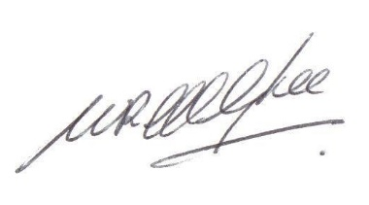
Ramsay McGhee
Grand Master Mason

